Supplementary manuscript of

Latent space search based multimodal optimization with personalized edge-network biomarker for multi-purpose early disease prediction

Jing Liang,1,2 Zong-Wei Li,1 Ze-Ning Sun,1 Ying Bi,1 Han Cheng,3 Tao Zeng4∗

and Wei-Feng Guo1,2,5*

1 School of Electrical and Information Engineering, Zhengzhou University,

Zhengzhou, 450001, China

2 State Key Laboratory of Intelligent Agricultural Power Equipment, Zhengzhou University, Luoyang, 471000, China

3 School of Life Sciences, Zhengzhou University, Zhengzhou,450001, China

4 Guangzhou National Laboratory, Guangzhou, 510005, China

5 State Key Laboratory of Oncology in South China, Collaborative Innovation Center for Cancer Medicine, Sun Yat-sen University Cancer Center, Guangzhou, 7510060, China

∗To whom correspondence should be addressed. [guowf@zzu.edu.cn](mailto:guowf@zzu.edu.cn), <zeng_tao@gzlab.ac.cn>

## Part A: The analysis of F-score for PDENB identified by MMPDENB-RBM and other algorithms

In order to explore why the F-score value of each algorithm are slow. We calculated two factors that affect the F-score, namely precision and recall. Where, precision denotes the proportion of correctly predicted cancer tissue specific biomarkers to all the predicted PDENBs, and recall denotes the proportion of correctly predicted cancer tissue specific biomarkers to the given gold standard cancer tissue specific biomarkers list.

It can be seen that the precisions of PDENBs recognition by most algorithms were usually higher than that of recall, which shows that compared with precision, lower recall was the main reason for low F-score(**Figs. S1-3**). The reasons can be summarized as follows.

1. After diving all algorithms into two categories: optimization algorithms (MMPDENB-RBM, MMPDNB, MOEA/PSL, and MP-MMEA) and traditional DNB algorithms (sDNB, L-DNB, and SPEN), we found that the precisions of the optimization algorithm were usually higher than that of the traditional DNB algorithms when the same number of special biomarkers were included. This is because the optimization algorithms were affected by objective function *f1* (i.e., minimizing the number of gene pairs of PDENB), the number of gene pairs constituting PDENBs was small. However, fewer gene pairs constituting PDENB mean fewer chances of containing more special biomarkers. Therefore, the recalls of optimization algorithms are little.
2. In essence, we used early-warning signal score to guide the MMPENB-RBM to identify a group of gene pairs that have dramatic fluctuations in the pre-disease state as PDENBs to detect critical state. However, special biomarkers (synthetic lethality edge-biomarkers, driver genes, and marker genes) may not have the properties to characterize critical states, so PDENBs may or may not contain biomarkers with special purposes. This was also consistent with the explanation in the DNB paper (Reference 25). “*Note that the purpose of this work is not to identify the parameters or factors that first drive the system into the disease state, but to identify the responsive DNB which first moves into the disease state driven by any known or unknown factors (or first reflects such a critical transition). Some molecules related to the driving factors (e.g., SNPs or CNVs) may or may not be in the DNB.*”

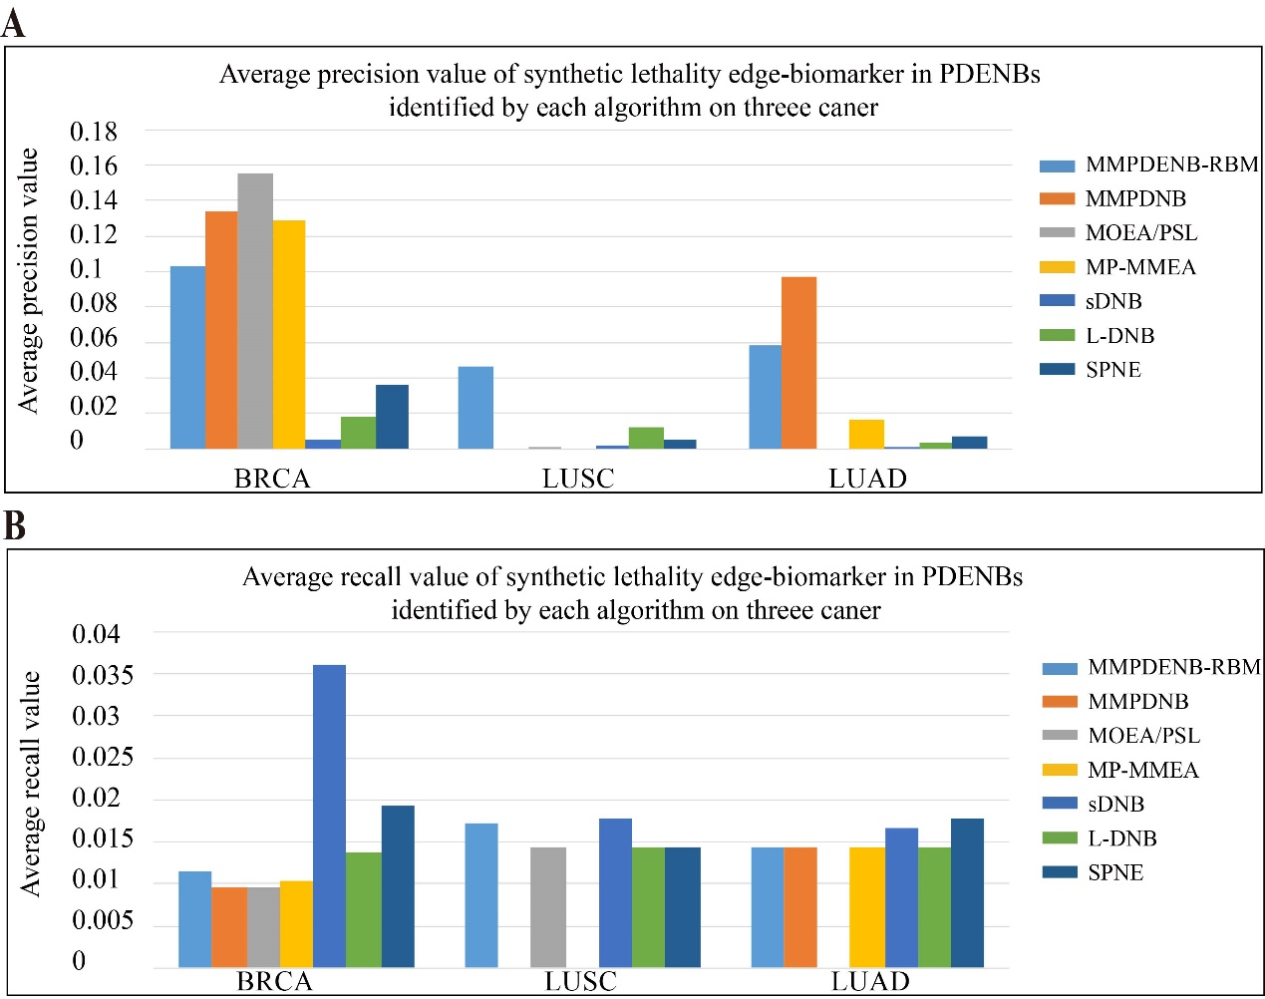

**Fig. S1 (A-B)** The average precision and recall of different algorithms for discovering synthetic lethality edge-biomarkers.

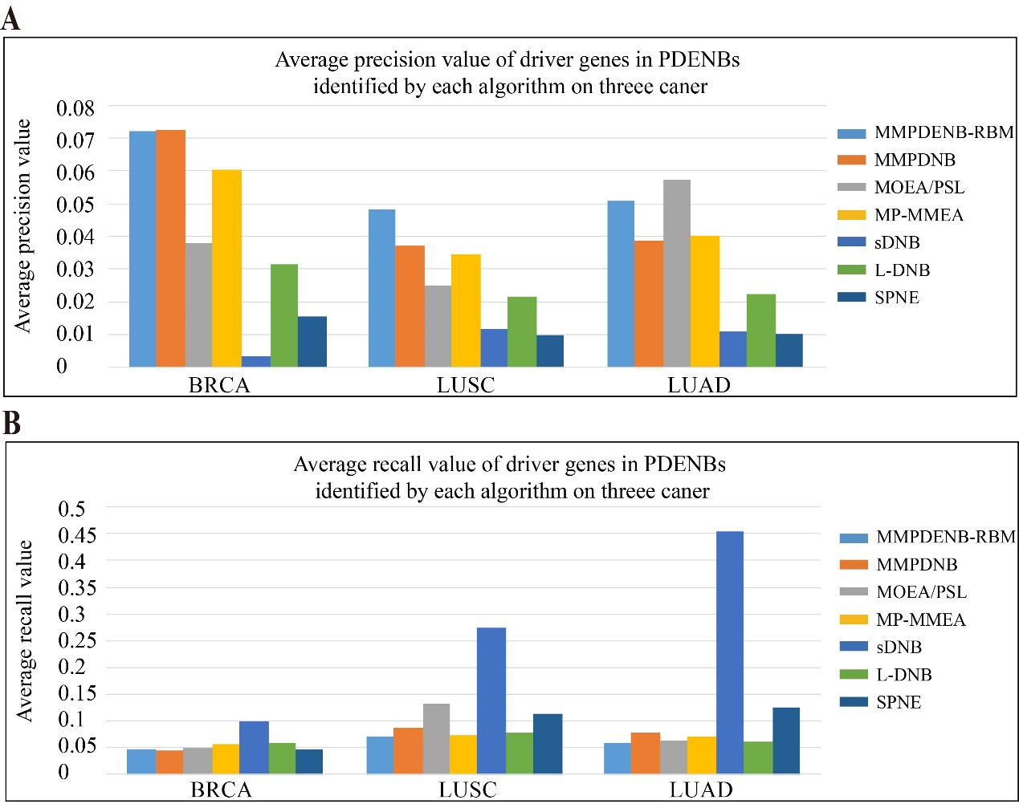

**Fig. S2 (A-B)** The average precision and recall of different algorithms for discovering driver genes.

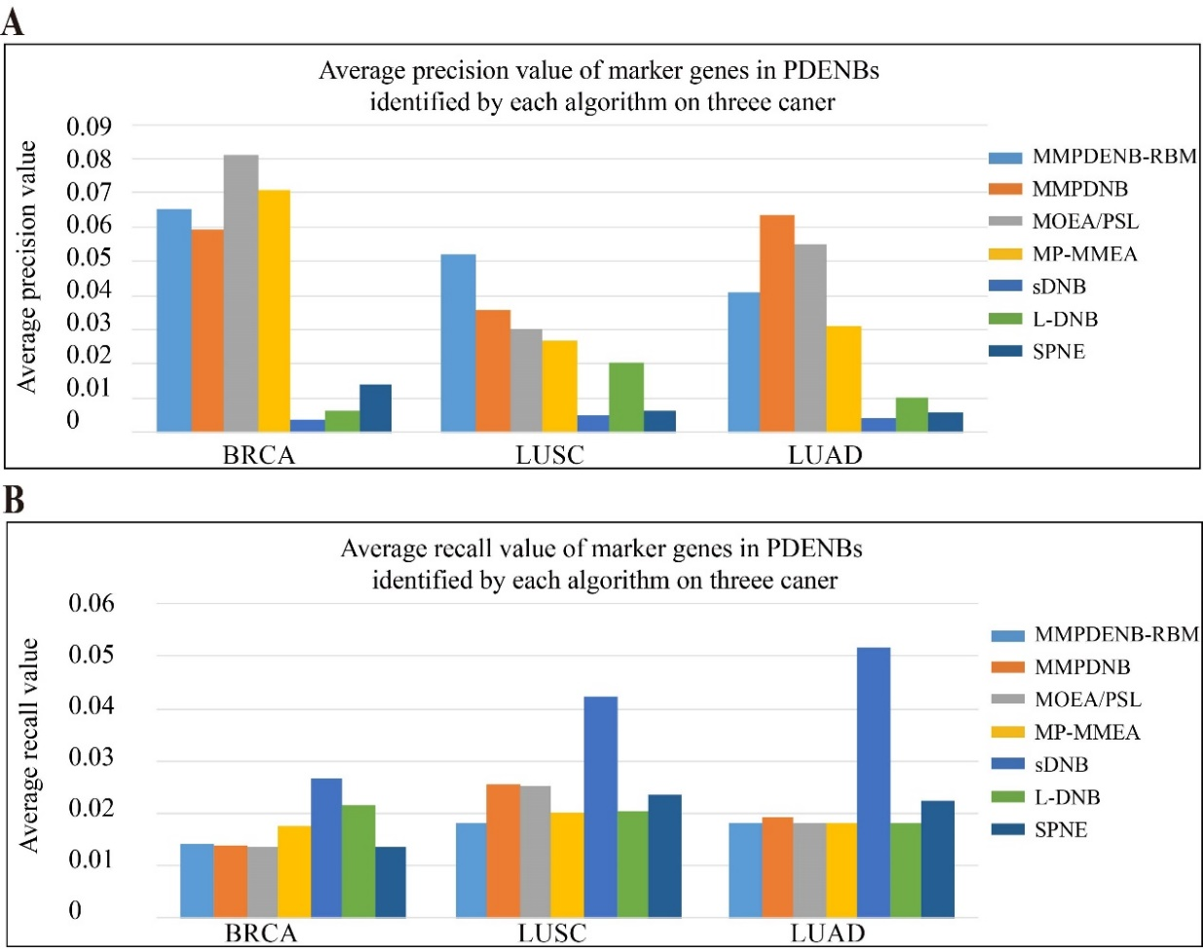

**Fig. S3 (A-B)** The average precision and recall of different algorithms for discovering marker genes.

However, MPEDP hopes that PDENBs can be used not only to detect critical state, but also have other purposes, so we used existing criteria as a reference to determine whether the PDENBs identified by MMPDENB-RBM have special biomarkers.

In order to find out whether the MMPDENB-RBM model and other algorithm were promising to identify the special biomarkers or not, we calculated the *P*-values of F-scores for the PDENBs. To obtain *P*-values of the F-scores for the PDENBs, we generated 100 random gene pairs sets, each of which have the same number of genes as PDENBs, and recalculated the F-scores of each random gene set. The random gene sets were used to obtain an empirical null distribution for the F-scores for random gene sets *SD*. Then we computed z-score as follow.

$z-\text{score}=\frac{F-mean(SD)}{std(SD)}$ (1)

where *F* is F-scores of PDNBs. SD is the distribution of F-scores generated from the random gene sets. The *mean* and *std* denote the mean value and standard deviation value of SD. Finally, based on z-score, we can obtain the empirical *P*-value of PDNBs on BRCA, LUAD and LUSC cancer datasets (modeled as Gaussian distribution).

From the results of **Figs. S4-6**, we can see that although the F-scores of MMPDENB-RBM seems low, MMPDENB-RBM has significant advantages over other algorithms and random selection method in general, and results of MMPDENB-RBM are statistically significant in identifying special biomarkers (*P*-value<0.05).

Although our algorithm seems to identify special biomarkers with low F-score caused by possible limitation from unsupervised, it has achieved some advantages compared with the existing DNB algorithms and random selection algorithm.

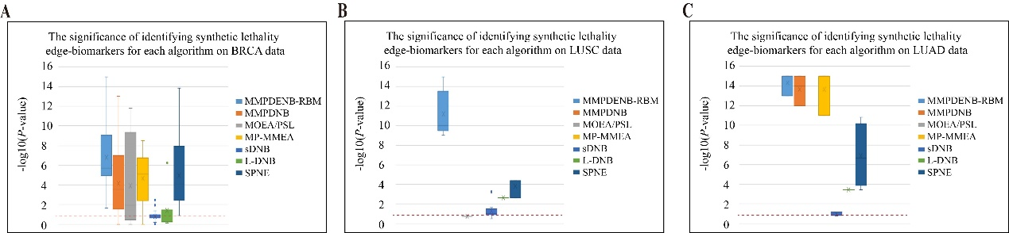

**Fig. S4 (A-C)** Significance of identifying synthetic lethality edge-biomarkers for each algorithm on three cancer datasets. The red dotted line denotes the significant threshold value as -log10(0.05). If the value is larger than this threshold value, the result is statistically significant.

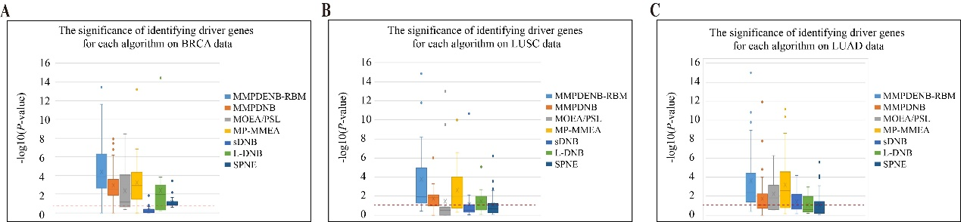

**Fig. S5 (A-C)** Significance of identifying driver genes for each algorithm on three cancer datasets. The red dotted line denotes the significant threshold value as -log10(0.05). If the value is larger than this threshold value, the result is statistically significant.

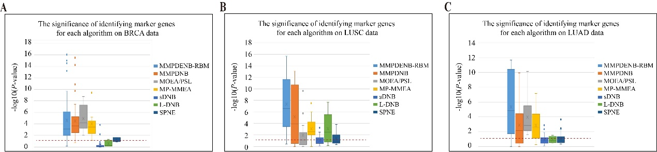

**Fig. S6 (A-C)** Significance of identifying marker genes for each algorithm on three cancer datasets. The red dotted line denotes the significant threshold value as -log10(0.05). If the value is larger than this threshold value, the result is statistically significant.